Defect D-08563

1. Need to remove extra "A note from [Name]:" as it is extra /duplication from message.
2. Remove break line so “View Wish List “ is in the same line.
3. Apostrophe missing in message.

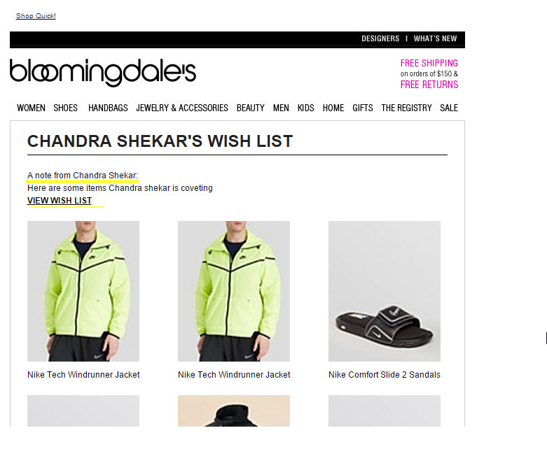

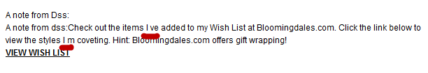

**Changes in the Code**

Code changes added are highlighted in **red** color, removed ones are **~~strikethrough~~**  and **BLUE** are same styles below

<**span style="~~color~~**~~:~~**~~#000~~**~~;~~ **color:#000001;font-family**:**Arial**,**sans-serif**;**font-weight**:**normal**;**font-size**:12**px**;**text-align**:**left**;**line-height**:18**px**;**margin**:0;**padding**:0**" align="left"**>  
~~A note from Emani: <~~**~~br~~**~~><~~**~~span~~** ~~>~~  
A note from emani: Check out the items I've added to my Wish List at Bloomingdales.com. Click the link below to view the styles I'm coveting.

Hint: Bloomingdales.com offers gift wrapping! ~~<~~**~~br~~**~~>~~

<**a href="http://www.qa13codebloomingdales.fds.com/wishlist/guest?wid=009ccc50-704a-4a4f-941a-e654e2ddd9a3&amp;cm_mmc=EML2-_-wishlist_share-_-BODY-_-View_Wish_List~~&amp;cm_mmc=wishlist-_-share-_-sil-_-n~~&amp;stop_mobi=yes" style="color**:**#000000**;**text-decoration**:**underline**;**font-weight**:**bold" target="_blank"**>  
VIEW WISH LIST  
</**a**>  
</**span**></**span**>

Defect D-08473

1. ' sign up now ' link It should navigate to " http://ebm.cheetahmail.com/r/regf2?a=0&aid=392907741&n=111 "

**Remove extra tags:**

 It's navigate to " http://ebm.cheetahmail.com/r/regf2?a=0&aid=392907741&n=111?cm_sp=EML2-_-wishlist_share-_-BOTTOMAD_LEFT-_-APPLICATION "

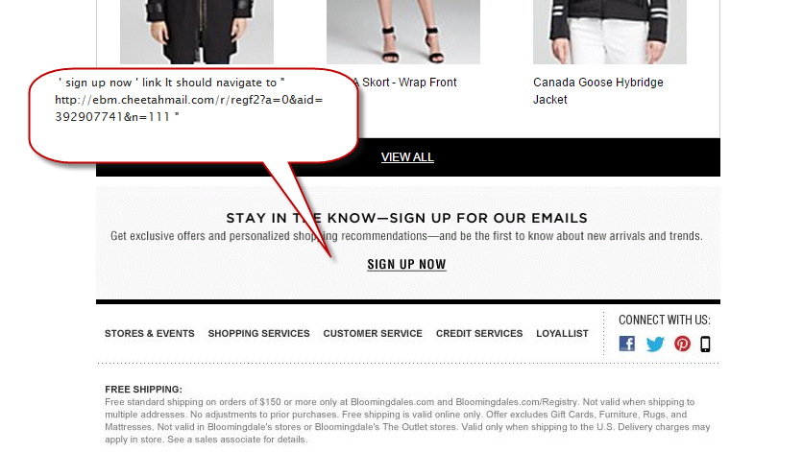

Defect D-08570

1. View Wish List and View All links CM tags are incorrect. The CM tag currently is &cm_mmc=wishlist-_-share-_-sil-_-n

Instead it should be: &amp;cm_mmc=EML2-_-wishlist_share-_-BODY-_-View_Wish_List"

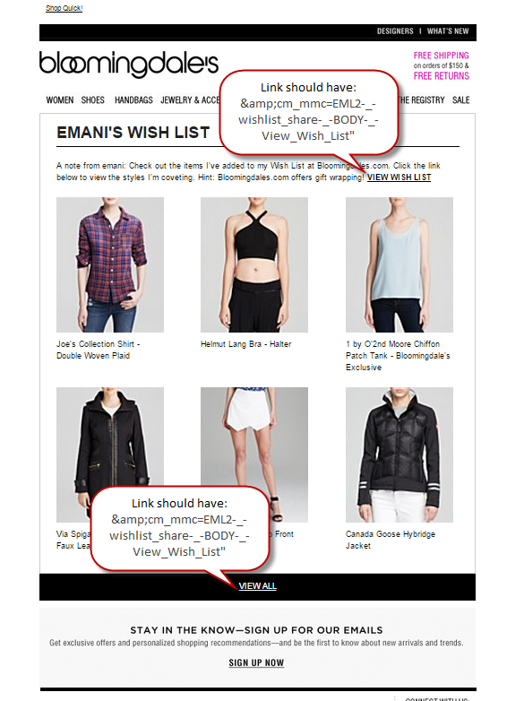

**Changes in the Code**

<**a href="http://www.qa13codebloomingdales.fds.com/wishlist/guest?wid=009ccc50-704a-4a4f-941a-e654e2ddd9a3&amp;cm_mmc=EML2-_-wishlist_share-_-BODY-_-View_Wish_List~~&amp;cm_mmc=wishlist-_-share-_-sil-_-n~~&amp;stop_mobi=yes" style="color**:**#000000**;**text-decoration**:**underline**;**font-weight**:**bold" target="_blank"**>  
VIEW WISH LIST  
</**a**>  
</**span**></**span**>

**Link for view all**

<**a style="font-size**:12**px**;**color**:**#ffffff**;**text-decoration**:**underline**;**display**:**block**;**font-family**:**arial**,**Helvetica**,**sans-serif" href="http://www.qa13codebloomingdales.fds.com/wishlist/guest?wid=009ccc50-704a-4a4f-941a-e654e2ddd9a3&amp;cm_mmc=EML2-_-wishlist_share-_-BODY-_-View_Wish_List~~&amp;cm_mmc=wishlist-_-share-_-sil-_-n~~&amp;stop_mobi=yes" target="_blank"**>  
VIEW ALL  
</**a**>  
</**td**>  
</**tr**>  
</**tbody**>  
</**table**>

Defect D-08636

1. Gmail adds class “im” changing the text font color and miss aligment

This defect happends when several emails are sent same subject /day. GMail thinks that parts of your message are inline replies to previous messages in a conversation.

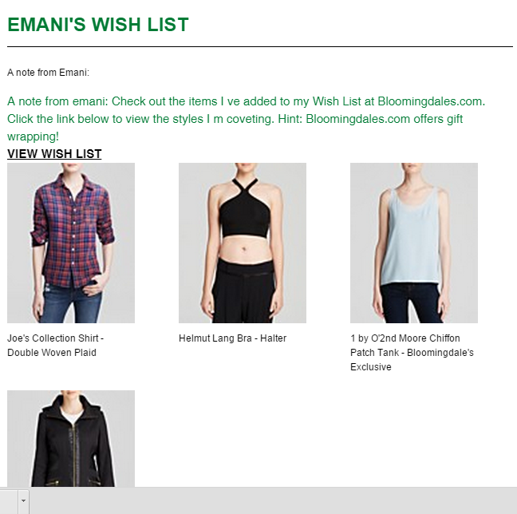

**Changes in the Code**

Tables were added for title section and also for email message

Line 115,130 had new tables.

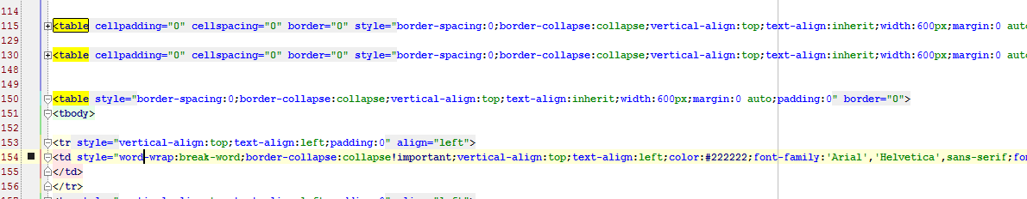

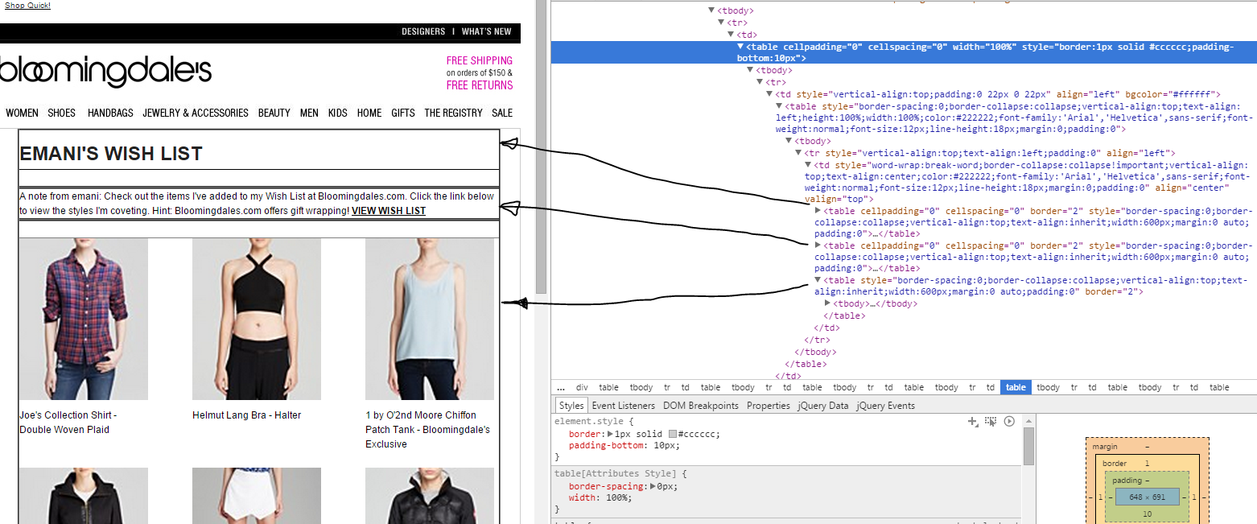

**Summary of ALL changes in the Template**

* - means code removed

+ means code added

|  |
| --- |
|  |
|  |
| 47 | 47 | <table width="650" border="0" cellspacing="0" cellpadding="0"> |
|  | 48 | <tbody> |
|  | 49 | <tr> |
| 50 |  | -<td width="650"><span class="im"> |
|  | 50 | +<td width="650"><span> |
|  | 51 |  |
|  | 52 | <table width="650" border="0" cellspacing="0" cellpadding="0" bgcolor="#000000"> |
|  | 53 | <tbody> |
|  | | @@ -110,29 +110,46 @@ |
|  | 110 | <tbody> |
|  | 111 | <tr style="vertical-align:top;text-align:left;padding:0" align="left"> |
|  | 112 | <td style="word-wrap:break-word;border-collapse:collapse!important;vertical-align:top;text-align:center;color:#222222;font-family:'Arial','Helvetica',sans-serif;font-weight:normal;font-size:12px;line-height:18px;margin:0;padding:0" align="center" valign="top"> |
| 113 |  | -<table style="border-spacing:0;border-collapse:collapse;vertical-align:top;text-align:inherit;width:600px;margin:0 auto;padding:0" border="0"> |
|  | 113 | + |
|  | 114 | + |
|  | 115 | +<table cellpadding="0" cellspacing="0" border="0" style="border-spacing:0;border-collapse:collapse;vertical-align:top;text-align:inherit;width:600px;margin:0 auto;padding:0"> |
| 114 | 116 | <tbody> |
| 115 | 117 | <tr style="width:100%;vertical-align:top;text-align:left;padding:0" align="left"> |
| 116 |  | -<td style="word-wrap:break-word;border-collapse:collapse!important;vertical-align:top;text-align:left;color:#222222;font-family:'Arial','Helvetica',sans-serif;font-weight:normal;font-size:12px;line-height:18px;margin:0;padding:0" align="left" valign="top"><span class="im"> |
|  | 118 | +<td style="word-wrap:break-word;border-collapse:collapse!important;vertical-align:top;text-align:left;color:#222222;font-family:'Arial','Helvetica',sans-serif;font-weight:normal;font-size:12px;line-height:18px;margin:0;padding:0" align="left" valign="top"> |
|  | 119 | + |
| 117 | 120 | <span align="left" style="font-family:Arial,sans-serif;font-size:24px;font-weight:bold;text-align:left;padding-top:20px;padding-bottom:10px;width:100%;float:left;clear:both"> |
| 118 | 121 | EMANI'S WISH LIST |
| 119 | 122 | </span> |
| 120 | 123 | <br> |
| 121 | 124 | <hr style="width:100%;color:#d9d9d9;min-height:0;clear:both;background:#d9d9d9;margin:0px 0px 20px;border-color:#000;border-style:solid;border-width:1px 0 0"> |
| 122 |  | -</span><span style="color:#000;font-family:Arial,sans-serif;font-weight:normal;font-size:12px;text-align:left;line-height:18px;margin:0;padding:0" align="left"> |
| 123 |  | -A note from Emani: <br><span class="im"> |
| 124 |  | -A note from emani: Check out the items I |
| 125 |  | -ve added to my Wish List at Bloomingdales.com. Click the link below to view the styles I |
| 126 |  | -m coveting. |
|  | 125 | +</td> |
|  | 126 | +</tr> |
|  | 127 | +</tbody> |
|  | 128 | +</table> |
|  | 129 | + |
|  | 130 | +<table cellpadding="0" cellspacing="0" border="0" style="border-spacing:0;border-collapse:collapse;vertical-align:top;text-align:inherit;width:600px;margin:0 auto;padding:0"> |
|  | 131 | +<tbody> |
|  | 132 | +<tr style="width:100%;vertical-align:top;text-align:left;padding:0" align="left"> |
|  | 133 | +<td style="word-wrap:break-word;border-collapse:collapse!important;vertical-align:top;text-align:left;color:#222222;font-family:'Arial','Helvetica',sans-serif;font-weight:normal;font-size:12px;line-height:18px;margin:0;padding:0" align="left" valign="top"> |
|  | 134 | + |
|  | 135 | +<span style="color:#000001;font-family:Arial,sans-serif;font-weight:normal;font-size:12px;text-align:left;line-height:18px;margin:0;padding:0" align="left"> |
|  | 136 | + |
|  | 137 | +A note from emani: Check out the items I've added to my Wish List at Bloomingdales.com. Click the link below to view the styles I'm coveting. |
| 127 | 138 | Hint: Bloomingdales.com offers gift wrapping! |
| 128 |  | -<br> |
| 129 | 139 |  |
| 130 |  | -<a href="http://www.qa13codebloomingdales.fds.com/wishlist/guest?wid=009ccc50-704a-4a4f-941a-e654e2ddd9a3&amp;cm_mmc=wishlist-_-share-_-sil-_-n&amp;stop_mobi=yes" style="color:#000000;text-decoration:underline;font-weight:bold" target="_blank"> |
|  | 140 | +<a href="http://www.qa13codebloomingdales.fds.com/wishlist/guest?wid=009ccc50-704a-4a4f-941a-e654e2ddd9a3&amp;cm_mmc=EML2-_-wishlist_share-_-BODY-_-View_Wish_List&amp;stop_mobi=yes" style="color:#000000;text-decoration:underline;font-weight:bold" target="_blank"> |
| 131 | 141 | VIEW WISH LIST |
| 132 | 142 | </a> |
| 133 |  | -</span></span> |
|  | 143 | +</span> |
|  | 144 | </td> |
|  | 145 | </tr> |
|  | 146 | +</tbody> |
|  | 147 | +</table> |
|  | 148 | + |
|  | 149 | + |
|  | 150 | +<table style="border-spacing:0;border-collapse:collapse;vertical-align:top;text-align:inherit;width:600px;margin:0 auto;padding:0" border="0"> |
|  | 151 | +<tbody> |
|  | 152 | + |
| 136 | 153 | <tr style="vertical-align:top;text-align:left;padding:0" align="left"> |
| 137 | 154 | <td style="word-wrap:break-word;border-collapse:collapse!important;vertical-align:top;text-align:left;color:#222222;font-family:'Arial','Helvetica',sans-serif;font-weight:normal;font-size:12px;line-height:18px;margin:0;padding:0" align="left" height="20" valign="top" width="100%"> |
| 138 | 155 | </td> |
|  | | @@ -337,7 +354,7 @@ |
|  | 354 | <tbody> |
|  | 355 | <tr align="center" style="vertical-align:top;text-align:left;padding:0"> |
|  | 356 | <td width="100%" valign="middle" bgcolor="#000000" align="center" style="font-size:12px;text-align:center;word-wrap:break-word;border-collapse:collapse!important;vertical-align:middle;color:#fff;font-family:Arial,sans-serif;font-weight:normal;line-height:18px;height:40px;background:#000000;margin:0;padding:0"> |
| 340 |  | -<a style="font-size:12px;color:#ffffff;text-decoration:underline;display:block;font-family:arial,Helvetica,sans-serif" href="http://www.qa13codebloomingdales.fds.com/wishlist/guest?wid=009ccc50-704a-4a4f-941a-e654e2ddd9a3&amp;cm_mmc=wishlist-_-share-_-sil-_-n&amp;stop_mobi=yes" target="_blank"> |
|  | 357 | +<a style="font-size:12px;color:#ffffff;text-decoration:underline;display:block;font-family:arial,Helvetica,sans-serif" href="http://www.qa13codebloomingdales.fds.com/wishlist/guest?wid=009ccc5033-704a-4a4f-941a-e654e2ddd9a3&amp;cm_mmc=EML2-_-wishlist_share-_-BODY-_-View_Wish_List&amp;stop_mobi=yes" target="_blank"> |
|  | 358 | VIEW ALL |
|  | 359 | </a> |
|  | 360 | </td> |
|  | | @@ -423,7 +440,7 @@ |
|  | 440 | </td> |
|  | 441 | </tr> |
|  | 442 | </tbody> |
| 426 |  | -</table><span class="im"> |
|  | 443 | +</table><span> |
|  | 444 | <table width="650" border="0" cellspacing="0" cellpadding="0" align="center"> |
|  | 445 | <tbody> |
|  | 446 | <tr> |
|  | |  |